The Dell, Cullingworth: Wildlife Survey, June 2010
Bradford Environmental Education Service (BEES – part of Bradford YMCA) have been asked by Shipley Area Coordinator’s Office to carry out a wildlife survey of The Dell at Cullingworth. The findings of this initial survey will inform decisions about the management required in the woodland to encourage greater community use in the future.
The Site
The Dell is a small area woodland adjacent to the footpath of the same name, leading from Dellside Gardens to Victoria Street. There are two sets of steps that enable access to the area, which appears to be used regularly by dog walkers. There is evidence of littering and a significant amount of dumping from the footpath and adjacent gardens. The footpath is a regular gathering point for young people.
The tree cover is dense and the canopy is closed in most areas, casting deep shade and limiting ground flora in some parts of the wood. There are several mature oak and sycamore trees and the number of young wych elm trees is notable. Many of the elms are reaching an age when they will be prone to infection by Dutch elm disease. This is a fungal disease that is transmitted by beetles and results in the death of the tree. Other tree species include holly, horse chestnut and poplar.
The ground flora is mixed with areas dominated by nettle, cow parsley and ivy, but also a good range of other woodland flowers. There are two woodland species - pink purslane and fringe cups – both naturalised in this country but fairly uncommon. 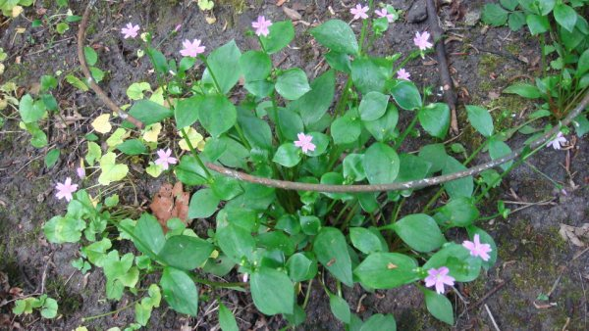 pink purslane (and discarded metal)
On the side nearest the footpath there is less ground vegetation as a result of the shade, but a contributing factor could be the presence of grazing chickens from an adjacent farm.
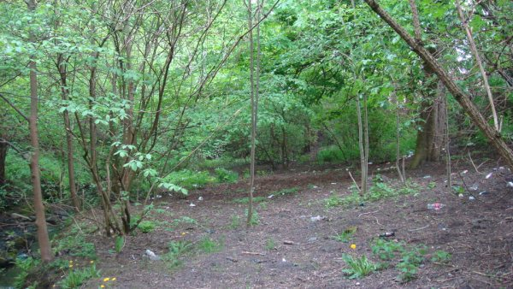 bare ground between the stream and the footpath
There are several species of flowering plant that are indicators of ancient woodland – a classification that indicates the woodland has not been disturbed for over 400 years providing a very rich wildlife resource. However, approximately ten species need to be recorded in unison to indicate ancient woodland and this survey lists five. A study of ordnance survey maps back to 1894 shows continuous woodland cover, but in all likelihood there has been some felling in the past.
A short walk to the next section of wood, Royd Wood, reveals a significant population of bluebells, another ancient woodland indicator. This area is on steeper slopes so most likely was not managed intensively.
Overview of recommendations
Woodland Management
The woodland is overgrown – this limits light reaching the woodland floor, so limiting ground flora in some areas, but also restricts access for people. Selective thinning will alleviate this
One of the most striking features of The Dell is the number of elm trees. At about the age of 12 the trees become susceptible to Dutch elm disease so it would be appropriate to introduce a management regime to ensure a varied age structure thereby ensuring a constant presence of the species. Coppicing – cutting the tree to ground level which encourages regrowth of many stems - on a 10 year cycle will reduce the incidence of infection.
Wych elm is the preferred breeding habitat for northern colonies of the white-letter hairstreak butterfly. Reduction in its food plant has severely reduced the occurrence of this butterfly. It is listed as one of the target species in Bradford Council’s Local Biodiversity Action Plan. Further survey work in the woodland, and investigation in the neighbourhood, will provide information to assist in deciding whether to manage The Dell with the butterflies in mind.

Ash, field maple and lime trees are also thought to be important for white-letter hairstreak so retention, or planting, of these around elm would be beneficial.

Tree Preservation Order
The trees in The Dell are covered by a Tree Preservation Order. Whilst offering protection to the woodland this also means that permission is required from the Council’s Tree Team before any management of the trees can be undertaken.
An application can be downloaded from the Council’s website and a decision should be known within eight weeks of receipt.
Access
As well as opening up the woodland, some physical changes will also encourage greater access. The existing steps are steep and need altering, in addition an extra filight of steps leading into the woodland is recommended. An informal path between the existing steps will give structure and improve the safety for public access.
Litter
Litter and dog fouling need to be addressed. A clean up will improve the site in the first instance but the problems are likely to reoccur unless the issues are tackled in more detail. Increased use and care of the site can have a positive affect on people who may currently consider it ‘wasteland’.
Habitat Improvements and educational opportunities
Bird and bat nest boxes could be made and erected in the woodland. Habitat opportunities could be improved by sensitive planting and creation of ‘habitat piles’ using fallen branches.
Surveys and identification sessions could be organised to increase people’s knowledge of the woodland and general environmental awareness.
Key Features and Recommendations
The accompanying sketch map on page 4 is numbered to indicate areas of note. The relevant detail is summarised in the table starting on page 5. Some recommendations are offered for future management. These are intended as a starting point and further consultation work would be required before a management plan can be written.
Conclusions
The Dell is a relatively diverse woodland with signs that it has existed for several hundred years, though it has probably been disturbed through its lifetime. It shows outward signs of neglect and misuse which limit its attraction as a community resource. Simple measures could be undertaken to improve access and the wildlife value of the wood, however any management of the trees must be approved by the Council’s Tree Team before work is undertaken.
Further specific survey work could ascertain presence of bats and butterflies, and more general environmental education sessions will enable the local community to increase knowledge and understanding as well as take positive action in their neighbourhood.
Development of a management plan will enable a consistent approach to the management of The Dell. It will identify the resources needed and will detail the timing of the management tasks.
The Dell offers great potential as a rich wildlife space for the Cullingworth Community. It already contains many wild plants and attracts a good mix of birds. With relatively little input The Dell could be vastly improved for local people.

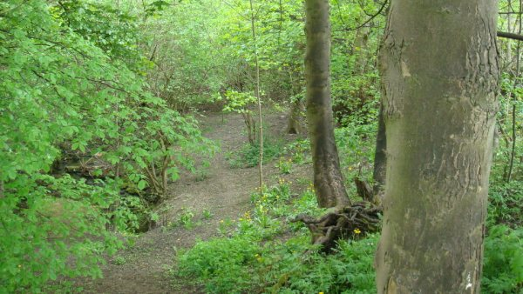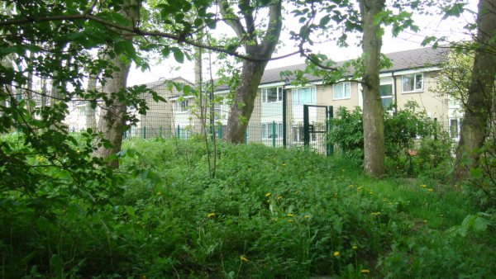
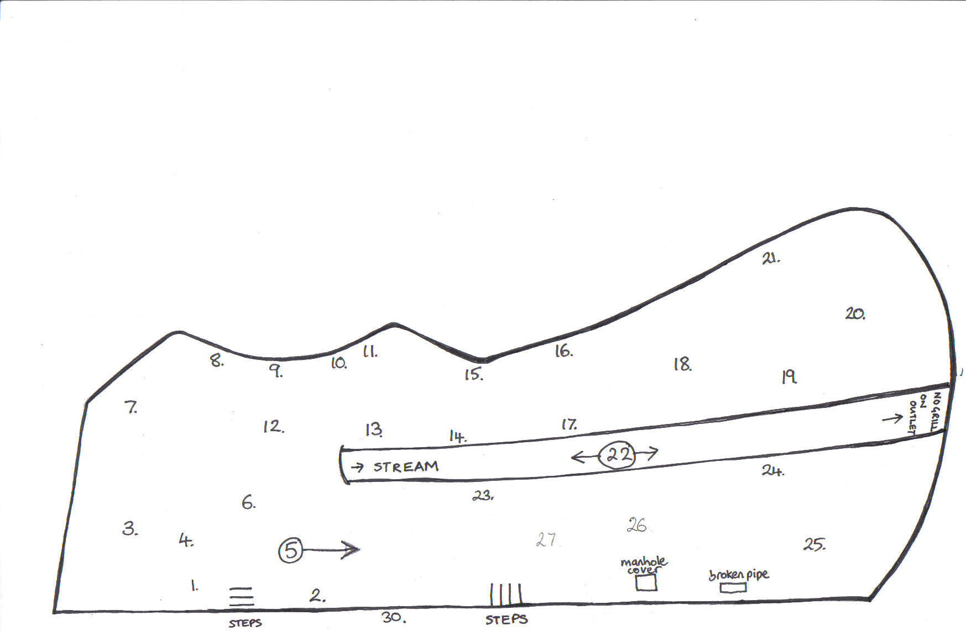
The Dell, CullingWorth, Wildlife Survey.
Key Features – use in conjunction with numbered text in table starting on page 5.
Footpath
Key Features and Recommendations.
This information refers to numbers located on the sketch drawing of The Dell. It gives information about areas of vegetation and key features of the site. Some recommendations are made for possible management approaches.
number | feature | recommendation
throughout | Elm trees | Introduce a 10 year coppice cycle to maintain young plants*  *with reference to TPO restrictions
1. | Small amount of snowberry | This is non-native shrub that spreads to form dense stands. It can offer a nesting habitat for small birds but if left unchecked will reduce the diversity of ground flora in the wood.  Cut back and grub out new stems.
2. | Several ash saplings next to wall that have been broken | The site of broken saplings at the edge of the wood presents an air of neglect and could encourage further misuse.  Coppice the ash saplings to ground level. They will grow back with main stems and provide a hedge boundary to the wood.
3. | Medium sized sycamore and many ash seedlings | Consider alteration of age structure by felling some trees*  *with reference to TPO restrictions
4. | Ground flora; nettle, dandelion, creeping buttercup, dock, wood avens, cleavers | No action
5. | Litter- glass and cans. There is a significant amount of litter throughout the section of the wood between the wall and the stream.  There is also a significant amount of dog fouling which would need to be addressed if the site was to be used by a broader section of the community. | The litter should be removed. Some of this could be done with community groups with the help of community wardens. There are a number of larger items e.g. a bike.  A further assessment of the site should be undertaken to ensure it is safe to invite community help.
6. | The pathway becomes steep and hazardous. | Construct steps to improve access and encourage use of woods. This could be extended to create an informal path along the side of the stream.
7. | Pile of grass cuttings. | This section seems to be regularly used to dispose of grass cuttings. Compost bins could be constructed here, which could also be used for other garden waste that is being dumped in the woods.
8. | Poplar hybrids. | No action
9. | Defunct fence. | Repair
10. | Garden rubbish dumped and burned. | Talk to neighbours. Encourage use of Council ‘green bags’ to dispose of garden waste instead of burning.
11. | Broken and partially burnt branches. | Cut and create habitat piles to reduce further fire risk. This will also improve shelter opportunities for small mammals and invertebrates.
12. | Holly seedling, ivy covering large area of ground. | No action
13. | Ground flora; enchanter’s nightshade, wavy bittercress, broad leaved willowherb, garlic mustard, lesser celandine, bramble. | No action.
14. | Possible Spanish bluebell | Confirm id and remove if it is Spanish Bluebell – this could hybridise with native species in adjacent woodland, which is undesirable.
15. | Large sycamore – potential bat habitat. | Undertake bat survey
16. | Oak, holly seedlings | No action
17. | sycamore and standing deadwood – good insect an bird habitat | No action
18. | Ground flora – pink purslane, meadow buttercup, creeping buttercup, foxglove, honeysuckle, bush vetch, ground ivy, ragwort, rosebay willowherb | No action
19. | Wilson’s honeysuckle | Monitor and control spread.
20. | Large oaks and sycamore, Elder shrubs | No action – but include in bat survey
21. | Broken wall | This could be reinstated –an opportunity to practise dry stone walling skills, but would need to negotiate with land owner.
22. | Stream contains a significant amount of debris, both fallen timber and rubbish. Some dead branches etc that alter the flow strength of water is good for the diversity of aquatic insects. | There is a very large trunk that if it is to be removed will require powered equipment. This needs further thought before an action is agreed.
23. | Bank –step, loose stones | Secure banking
24. | Vegetation includes lady fern, fringe cups, herb robert | No action
25. | Hens grazing | The hens may be a factor in the lack of ground flora in this area, but this needs further investigation before an action is agreed. The owner may be a positive guardian of the woods.
26. | Little ground flora | To increase the ground flora it may be necessary to increase the light reaching the woodland floor. Seeds or seedlings could be planted but would need to consider if the hens would eat them.
27. | Large horse chestnuts and sycamores
28. | Broken pipe | Should be mended
29. | Manhole in brick frame
30. | Coping stones missing from wall top | Could be replaced – investigate if still in woodland.

The Dell, Cullingworth.
Species lists - survey 19 May 2010
trees and shrubs |  |  |  | birds
Acer pseudoplatanus | Sycamore |  |  | Prunella modularis | dunnock
Aesculus hippocastanum | Horse Chestnut |  |  | Erithacus rubecula | robin
Fraxinus excelsior | Ash |  |  | Turdus merula | blackbird
Ilex aquifolium | Holly |  |  | Pica pica | magpie
Populus agg. | Poplar hybrid |  |  | Fringilla coelebs | chaffinch
Quercus robur | Oak |  |  | Streptopelia decaocto | collard dove
Sambucus nigra | Elder |  |  | Troglodytes troglodytes | wren
Ulmus glabra | Wych Elm
flowers and grasses
Alliaria petiolata | garlic mustard
Anthriscus sylvestris | cow parsley
Cardemine flexuosa | wavy bittercress (tbc)
Chamaenerion angustifolium | rosebay willowherb
Circaea lutetiana | enchanter's nightshade
Cotoneaster | cotoneaster
Dactylis glomerata | cocksfoot
Digitalis purpurea | foxglove
Endymion/hyacinthoides hispanicus | spanish bluebell
Epilobium montanum | broad leaved willowherb
Galium aparine | cleavers
Geranium columbinum | herb robert
Geum urbanum | wood avens
Glechoma hederacea | ground ivy
Hedera helix | ivy
Lonicera nitida | Wilson's honeysuckle
Lonicera periclymenum | honeysuckle
Meconopsis cambrica | welsh poppy
Montia sibirica | pink purslane
Poa trivialis | rough meadow grass
Ranunculus acris | meadow buttercup
Ranunculus ficaria | lesser celendine
Ranunculus repens | creeping buttercup
Rubus fruticosus | bramble
Rubus idaeus | raspberry
Rumex obtusifolius | broad leaved dock
Senecio jacobaea | ragwort
Stachys sylvatica | hedge woundwort
Symphoricarpos alba | snowberry
Taraxacum officinale agg. | dandelion
Tellima grandiflora | fringe cups
Urtica dioica | nettle
Vicia sepium | bush vetch
ferns
Athyrium filix-femina | lady fern
Dryopteris dilatata | broad buckler fern
Dryopteris filix-mas | male fern
Phyllitis scolopendrium | hartstongue fern
Further information
- Application for alteration for trees with a Tree Preservation Order http://www.planningportal.gov.uk/uploads/appPDF/Help031_england_en.pdf
- Bradford’s Local Biodiversity Action Plan
http://www.bradford.gov.uk/NR/rdonlyres/8D3547E2-FA86-4390-A74D-A335F3086B9F/0/BRADFORDBIODIVERSITY.pdf
- White-letter Hairstreak
http://www.butterfly-conservation.org/Butterfly/32/Butterfly.html?ButterflyId=52
- Ancient woodland,
P Glaves et al (2009), A Report to the Woodland Trust, Field Surveys for Ancient Woodlands: Issues and Approaches, Sheffield Hallam University.

